Roll No:241901120
Name: L.Ubendra
Department: CSE-Cyber Security
DEVELOP A SIMPLE CALCULATOR USING XML-RPC
Aim:
To develop a simple calculator using XML-RPC that performs basic arithmetic operations like addition, subtraction, multiplication, and division between two numbers.
ALGORITHM:
Server:
1.Start the server program.
2.Import the XML-RPC library.
3.Define functions for add, subtract, multiply, and divide.
4.Register these functions with the XML-RPC server.
5.Run the server and wait for client requests.
Client:
1.Start the client program.
2.Import the XML-RPC library.
3.Connect to the XML-RPC server using its URL.
4.Call the required calculator function (add, subtract, etc.) with input values.
5.Display the result returned by the server.
6.Stop the program.

PROGRAM:
Server:
Server.py
From xmlrpc.server import SimpleXMLRPCServer def add(a,b):
return a+b
def sum(a,b):
return a-b
def mul(a,b):
return a*b
def div(a,b):
return a/b
def mod(a,b):
return a%b
server=SimpleXMLRPCServer((“localhost”,8000)) print(“Listening on port 8000…”)
server.register_function(add,”add”)
server.register_function(sub,”sub”)
server.register_function(mul,”mul”)
server.register_function(div,”div”)
server.register_function(mod,”mod”)
server.server_forever()
Client:
Client.py

Import xmlrpc.client
proxy=xmlrpc.client.ServerProxy(‘http://localhost:8000/’)
for i in range(5):
a=int(input(“Enter a number:”))
b=int(input(“Enter b number:”))
print(“addition of given number is %d ”%((proxy.add(a,b)))) print(“sub of given number is %d ”%((proxy.sub(a,b)))) print(“mul of given number is %d ”%((proxy.mul(a,b)))) print(“div of given number is %d ”%((proxy.div(a,b)))) print(“mod of given number is %d ”%((proxy.mod(a,b))))
OUTPUT:
Server:
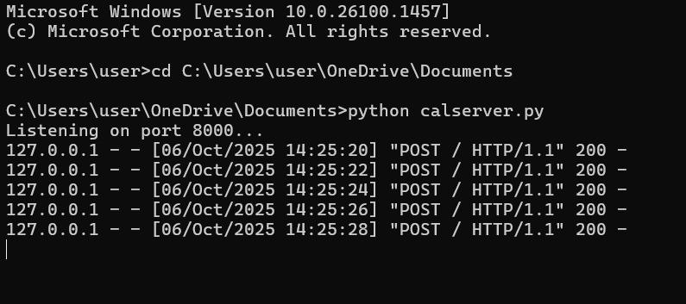

Client:
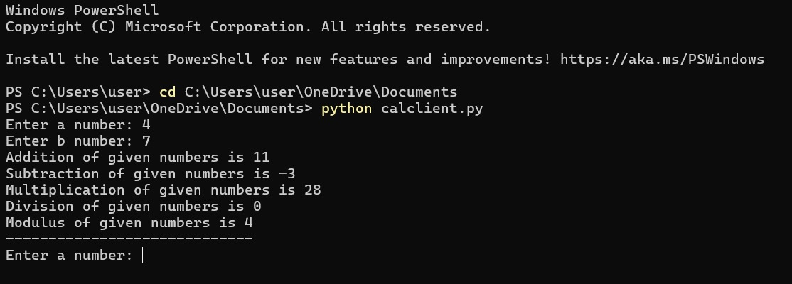
Result:
A simple calculator using XML-RPC in python is successfully developed and performed arithmetic operation.

